Granger Rightmove API Exploration
- Building amenities
- Unit outdoor space
- Unit: Pet friendly
- Building: Pet friendly
- Unit amenities

Rightmove Listing for Building Update flow (assuming that it is active):

Building: Pet friendly
The decision statement checks if building: pet-friendly has been changed within the record
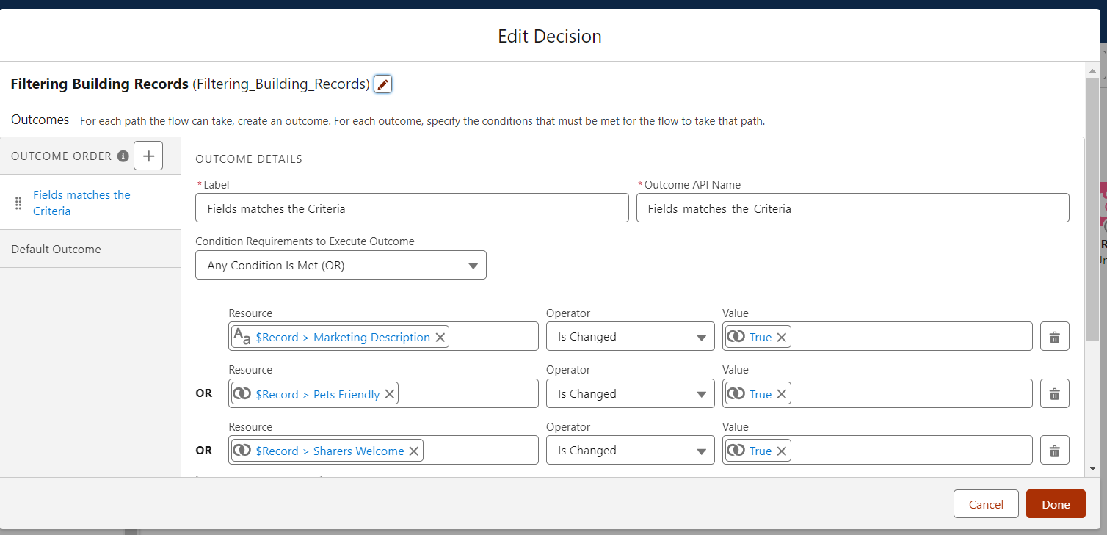
The remaining records are possibly passed to the API Looking at the provided code, but there isn't a direct reference to any of the fields. The retrieveListingDetails method is called to fetch listing details, but it's not clear from the code if the fields are included in the retrieved data.

In the apex code, retrieveListingDetails is called to fetch listing details associated with a particular unit ID (this.unitId).

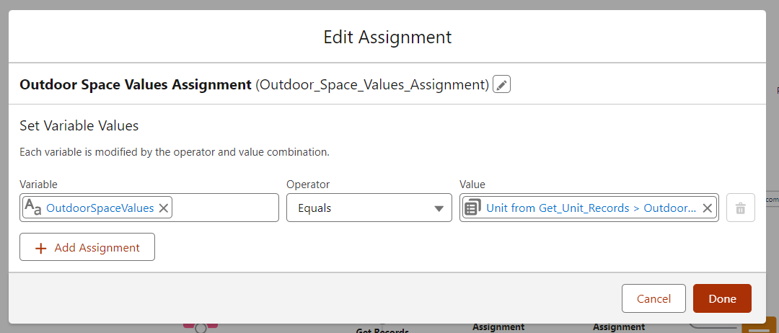

Publish/Unpublish Listing flow:

Unit outdoor space:
There is a lookup to a unit’s outdoor space values and those values are assigned to a variable called OutdoorSpaceValues.
This is later passed into the Listing apex class that runs the aforementioned retrieveListingDetails method.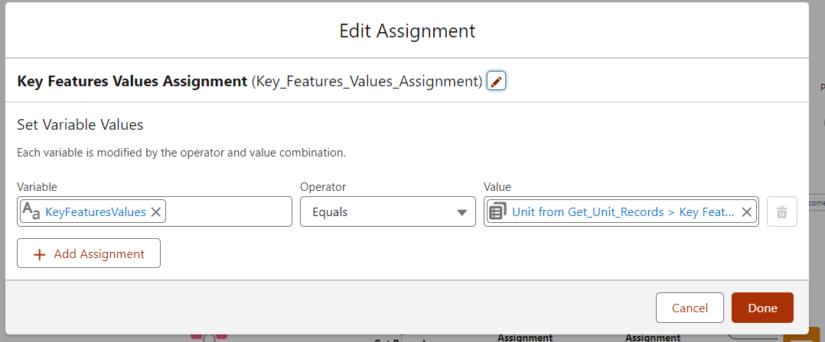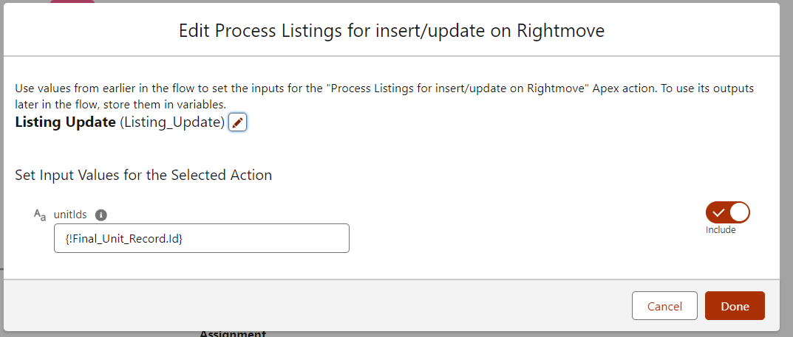

The following are the Key feature values that are being passed to the listing apex class:
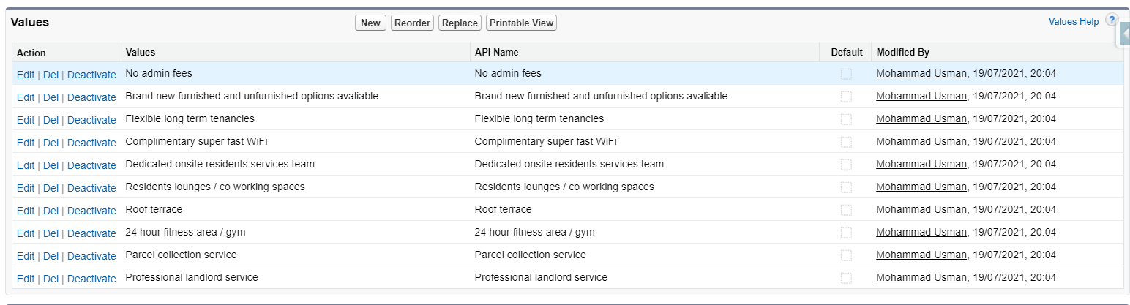

How data is passed to Rightmove:
The RightmoveListingProcessor class passes all unit data to the Rightmove API.
This class orchestrates the process of communicating with the Rightmove API to publish or remove listings, handles responses, and manages error logging.

The Salesforce Apex class named RightmoveListingRequest passes data between salesforce and the RightMove API.

